Week 7: Converting to a Distance Learning Format
George Briceno
EDUC 6135
Walden University
Dr. Celeste Fenton
May 24, 2018

Contents

Introduction 3
Blended Learning 3
Pre-Planning 4
Planning 5
Analysis 5
Design 6
Development 7
Implementation 7
Evaluation 8
Final Note 9
References 10

Introduction

This purpose of this guide is to aid a trainer in converting his or her program to a distance learning format that will adhere to the best practices necessary for a successful conversion. This guide will include suggestions that can assist the trainer to facilitate communication and learning among the trainees. The focus is on the Blended Learning format. This format provides the trainer the opportunity to interact with the trainees in a physical and online face-to-face environment.

Blended Learning
There are many definitions for Blended Learning. Torrisi (2011) in her study lists quite a few of which some are listed here: Singh and Reed (2001) define blended learning as “learning using a variety of instructional modalities”. Maise (2006) states that “all learning is blended… [it is] the use of two or more styles of content or context delivery or discovery”. Verkroost et al (2008) define it as “the total mix of pedagogical methods, using a combination of different learning strategies with or without technology”. Thorne (2003) states that it is “a way of meeting the challenges of tailoring learning and development to the needs of individuals by integrating the innovative and technological advances offered by online learning with the interaction and participation offered in the best of traditional learning”.
This last definition is key in that the idea of “integrating” is crucial to a blended learning environment. Blending is integrating. If blended learning is to impact in a positive way the quality of learning and teaching then an integrated approach rather than a superficial approach will force enriched strategies to surface from creative minds sharing thoughts and ideas.

Pre-Planning
During the pre-planning stage, the instructional environment “should be viewed as a system, a relationship among and between all the components of that system – the instructor, the learners, the material, and the technology” (Simonson et al, 2015). A popular framework for designing and developing training programs that cover the full instructional environment is “ADDIE”. ADDIE is an acronym for Analyze, Design, Develop, Implement, and Evaluate (Kurt, 2018). Two popular ADDIE models are depicted in figures 1 and 2.
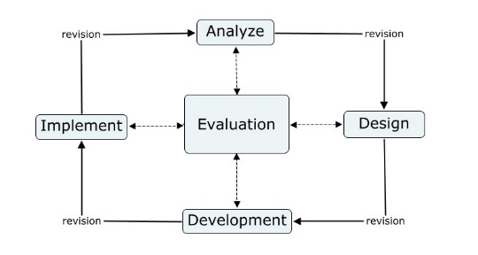
Figure 1 ADDIE Model 1
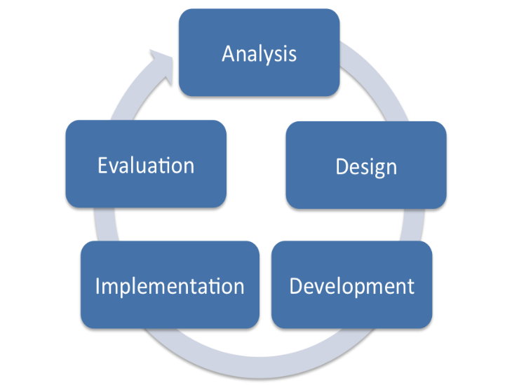
Figure 2 ADDIE Model 2
The trainer should start to consider and mentally masticate how the course needs to be taught, what is the main objective of the course and how are the trainees going to achieve the goal(s) that the trainer is going to set. Then the trainer should develop a course description complete with clear and defined learning goals (Laureate Education, n.d.).

Planning
For the planning this guide will utilize the ADDIE model. However, this guide will not be all inclusive of all available possibilities, and it is recommended that the trainer further research the ADDIE model through other sources and work closely with an Instructional Designer (ID) and a Subject Matter Expert (SME). What follows are brief descriptions of each stage and what questions or issues each addresses.

Analysis
This is the “goal-setting” stage. Here the trainer will focus on the trainee. The trainer will determine what topics the trainees already know so as to not duplicate those topics. The focus will be on new topics, knowledge and what the trainee should know after completing the course. This stage addresses the following:
- Determine the typical background information of the trainees who will utilize the program such as their age, nationality, cultural background, previous educational and work experiences and interests. Who will you be teaching? What are their educational goals? What are their knowledge levels on the material being taught?
- What do the trainees need to accomplish by the end of the course? What are their necessities?
- What will be required in terms of skills, intelligence, outlook and physical/psychological action-reaction? What are the desired learning outcomes in terms of knowledge, skills, attitudes, behavior etc.?
- Look into widely used teaching methods surrounding the subject and, if used, determine what can be developed and improved. Search for existing instructional techniques that are currently being used by other programs. Can you use them and will they suffice in this course?
- Determine the final objectives of this project. What instructional objectives does the project emphasize?
- In regards to the learning environment options that are available. For this project, the most conducive learning environment is what? Should discussions be synchronous, asynchronous or both? What delivery option will be used to transfer knowledge? Are you partial to using online, f2f, or a combination of the two? If you prefer online, have you given consideration to the differences in learning outcomes between classroom-based learning and web-based learning? If not, how will you determine the advantages of one over the other?
- In regards to the limiting factors in the overall objective of the program. Can you list some existing limiting factors that are due to resources, such as hardware, technical knowledge, support, time, human resources, financial and support factors? (Kurt, 2018)

Design
This stage concentrates on developing learning goals using content and subject matter analysis. It also focuses on exercises, lesson planning, assessment tools and media choices. This is a critical stage in that the ID needs to pay close attention to detail in order for this stage to be successful. The ID should be logical and systematic in his or her approach in designing for the courses’ objectives and goals. Things to take into consideration:
- In regards to the media to be used for the course such as audio, video and graphics, will you be using third party tools and programs or will the IDs develop their own? Are you going to prepare the teaching material?
- Is the level and types of activity going to be collaborative, interactive or adaptive to each trainee?
- Using a teacher’s style approach, how will you implement the parts of the project (i.e. behaviorist, constructivist, etc.)?
- Have you determined how much time is needed for each task? How will learning be employed (per lesson, chapter, module)? Will the lessons, or modules, follow a linear progression in presentation (i.e. easy to difficult)?
- What are the different mental processes, or cognitive skills, needed by the trainees in order for them to attain the learning objectives of the project?
- Have you determined how to evaluate if the trainee has acquired the knowledge and skill developed after each task? What method do you plan to use to determine the acquisition of desired knowledge and skills by the trainees?
- If you are going to be using a web-based project, have you given consideration to the website template or framework that you will be using? What kind of interface will the trainee be required to use?
- What type of feedback assessment will you use to evaluate if the trainees are able to comprehend the teachings?
- Understanding that there is a plethora of trainee preferences and learning styles, have you considered what technique to employ that will guarantee that the program will fit their needs? How will you strategize the activities so that they encompass the various learning styles and interests of the trainees? Will you choose to use a variety of delivery methods and media types? (Kurt, 2018)

Development
In this stage, the data gathered from the two previous stages is used to develop the program that is going to be used by the trainers and the trainees. This phase encompasses three tasks, designing, developing and testing. The developers need to assess the answers to the following questions:
- Is the timeframe being followed according to what has been accomplished in regards to material developed? Are the materials being created according to the timeframe?
- Do you see team work across various participants? Are the members working effectively as a team?
- Are participants contributing as per their optimal capacity?
- Are the materials produced up to task on what they were intended for? (Kurt, 2018)

Implementation
This stage is where the program is placed into service with trainers and trainees for the detection of faults and betterments. Continuous improvements by the IDs working with the participants who will be using the program are performed at this stage. The key at this stage is communication in the form of feedback from the participants to the IDs to the developers. The communication between the participants is important because it aids with clarification on tasks, technical and personal issues (Simonson et al, 2015). With the participation of all stakeholders, there is a greater likelihood of having an effective and successful program. Questions and suggestions that can help at this stage:
- Advise on your preferred method of record keeping, as well as the actual data you would like to mine from the experience of students interfacing with the project.
- What kind of emotional feedback are the trainers and trainees providing you during initial demo of the program? Are they genuinely interested, eager, critical or resistant?
- As the project proceeds, do you see that IDs are able to grasp the topic immediately or do they need help?
- Explain how you are going to deal with any possible errors during testing. What will your response be if, after presenting activities to students, things do not go as planned?
- Did you prepare a back-up tool in the event of initial failure of the project? When technical and other problems arise do you have a back-up strategy?
- Will you go for implementation on a small scale or a large scale?
- When the student group gets the material can they work independently, or is constant guidance required? (Kurt, 2018)

Evaluation
This final stage is where the program goes through rigorous testing in order to determine if the criteria of what, how, why and the when items are accomplished (or not accomplished) for the full project. The main objective of this stage is to determine if the goals of the project have been met. Important questions to answer and items to consider at this stage are:
- Determine the categories that will be established to evaluate the effectiveness of the project (i.e. improved learning, increased motivation etc.) On what factors or criteria will the effectiveness of project be determined?
- Determine the way you will implement data collection, as well as the timing at which it will be effectively made. When will the data related to the project’s overall effectiveness be collected and how?
- Determine a system for analyzing participant feedback.
- Determine the method to be used if some parts of the project need to be changed prior to full release. On what basis will you arrive at a decision to revise certain aspects of the project before its full implementation?
- Determine the method by which reliability and content validity can be observed.
- Determine the method by which you will know if instructions are clear. How is the clarity of instructions assessed?
- Determine the method by which you can analyze and grade the response of the participants on the project.
- Determine who gets to receive your final output regarding the project. Who will prepare this report on the results of the evaluation? (Kurt, 2018)

Final Note
Having completed the development of the program using the ADDIE model, the program is ready for use in a learning environment. However, it is important to remember that even though the program is in use, it is still dynamic and subject to improvements as technology advances and knowledge increases.

References
Kurt, S. (2018). ADDIE Model: Instructional Design. Educational Technology website. Retrieved from https://educationaltechnology.net/the-addie-model-instructional-design/
Laureate Education. (Producer). (n.d.). Planning and designing online courses. [Video File] Retrieved from https://class.waldenu.edu
Torrisi, G. (2011). Research and Development in Higher Education: Reshaping Higher Education. Volume 34. 34th HErDSA Annual International Conference 4-7 Jully 2011. Retrieved from https://research-repository.griffith.edu.au/handle/10072/42960
Simonson, M., Smaldino, S., & Zvacek, S. (2015). Teaching and learning at a distance: Foundations of distance education. (pp. 32-33)

